<https://nasdaqtrader.com/Trader.aspx?id=TradeHalts>

Need python script to scrape and append the new rows in the table in the screenshot as a Halts.xlsx file in Data subfolder. I am enclosing a script that uses geckodriver.

**Note;**

If possible, python scraper script should not use selenium automation (chromedriver or geckodriver). In case not possible, script should use geckodriver instead of chromedriver as it is available in 64 bit version and should perform better.

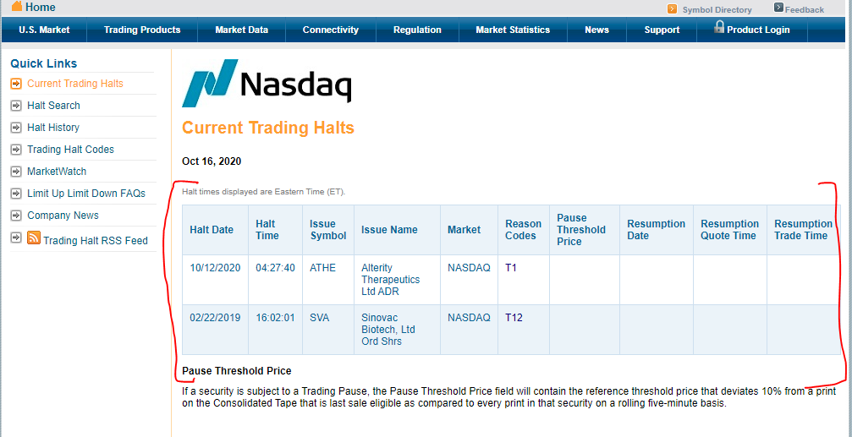

Columns; Issue Name & Pause Threshold Time not needed.

PostgreSQL halts table definition

CREATE TABLE public.halts

(

halt_date date NOT NULL,

halt_time time without time zone NOT NULL,

symbol character varying(10) COLLATE pg_catalog."default" NOT NULL,

market character varying(10) COLLATE pg_catalog."default",

code character varying(10) COLLATE pg_catalog."default",

resume_date date,

resume_quote_time time without time zone,

resume_trade_time time without time zone,

CONSTRAINT halts_pkey PRIMARY KEY (halt_date, halt_time, symbol)

)

TABLESPACE pg_default;

ALTER TABLE public.halts

OWNER to postgres;

**Resources;**

1. Database credentials will be provided in Control.csv
2. Location of News_Excel_File.xlsx specified in Control.csv located in the Control subfolder.
3. Control.csv provides info. needed to send email (SMTP server details as and Email To)
4. Control.csv provides info. about minimum volume (found in News_Excel_File.xlsx for each symbol) requirements for sending the email.
5. Check Frequency in Minutes provided in Control.csv for Checking the web page for new rows.

**Steps;**

1. Reject rows where Halt Date is before Today’s Date
2. Check whether row is already available in halts table based on primary key.
3. If found, don’t send email unless there was no Resumption Quote Time or Resumption Trade Time Specified in the database row before, but is specified now. If yes, send email & Update (insert or modify) the database.
4. If not found.
   1. Check whether Resumption Date or Resumption Quote Time not specified. If no, don’t send email, but update database.
   2. If Resumption Date or Resumption Quote Time specified, check whether volume (found in News_Excel_File.xlsx for each symbol) is greater than minimum volume specified in Control.csv.
   3. If Volume is greater than send Email.
   4. Update (insert or modify) the database.
5. Email contains relevant row from News_Excel_File.xlsx for the symbol. Control.csv contains the location of News_Excel_File.xlsx
6. One separate email for each new row.
7. Append new Rows to Halts.xlsx

**Email Contents;**

**Subject** should be structured as follows;

:Nasdaq Halt:<Symbol> (from Issue symbol Column):Res; <Resumption Time> in h:mm:ss AM/PM format (From Web Page Resumption Trade Time):Code; <Reason Code> (From Web Page Reason Codes):Vol;<Volume> Number expressed in Thousands. w/o decimals and with commas for thousands (from News_Excel_File.xlsx, column 12 Volume T):Flt Sht;<Float Short> Percentage with 2 decimals (from News_Excel_File.xlsx, column 20 Float Short):Days; <Days> w/o decimals and with commas for thousands (from News_Excel_File.xlsx, column 19 Days Vol):McapM; <Market Cap M> Number expressed in Millions. $ sign w/o decimals and with commas for thousands (from News_Excel_File.xlsx, column 6 Market Cap M):Price; <Price>$ sign with decimals and with commas for thousands (from News_Excel_File.xlsx, column 33 Price)

**Body** will contain HTML Table structured as follows;

Column Wise Formats;

All Dates; dd-Mmm-yy

All Times; h:mm:ss AM/PM

Reason Code; “LUDP “ & “M “ 🡪 Red with Red Fill & “M “ 🡪 Yellow with Yellow Fill

Vol; Number expressed in Thousands. w/o decimals and with commas for thousands (from News_Excel_File.xlsx, column 12 Volume T). Below 400K 🡪 Red with Red Fill, 400.00000001K to 750K 🡪 Yellow with Yellow Fill & Above 750K 🡪 Green with Green Fill

Flt Sht; Percentage with 2 decimals (from News_Excel_File.xlsx, column 20 Float Short). Greater than 5% 🡪 Green with Green Fill

Days; w/o decimals and with commas for thousands (from News_Excel_File.xlsx, column 19 Days Vol). Less that 30 🡪 Green with Green Fill, 30 to 90 🡪 Yellow with Yellow Fill

Price; $ sign with decimals and with commas for thousands (from News_Excel_File.xlsx, column 33 Price). Price Less than $5 🡪 Red with Red Fill

M Cap M; Number expressed in Millions. $ sign w/o decimals and with commas for thousands (from News_Excel_File.xlsx, column 6 Market Cap M). M Cap M Less than $500 🡪 Green with Green Fill

|  |  |  |  |  |  |  |  |  |  |  |
| --- | --- | --- | --- | --- | --- | --- | --- | --- | --- | --- |
| **Time** | **Sym** | **Reason Codes** | **Res DT** | **Res QT TM** | **Res TRD TM** | **Vol** | **Flt Sht** | **Days** | **Price** | **M Cap M** |
| 4:01:25 AM | SGRP | LUDP | 14-Jun-21 | 5:00:00 PM | 5:05:00 PM | 168 | 0.97% | 75 | $1.49 | $30 |